Veronique et Bernard Galy-fajou
Moulin du Chapitre,81540 Soreze
tel : 00-33-(0)5-63-74-18-18
moulin.chapitre@wanadoo.fr
How to get to the Moulin du chapitre?
Gps: longitude/2°3’9”E, latitude/43°26’51’’N
A.coming from TOULOUSE:
- On the highway (?),take the exit n°18
- Drive on the D.622 until REVEL
- Once in REVEL, follow teh main road which goes around the city and to take D.1, direction SOREZE, which becomes D.85 in the Tarn.
- Drive 2.5 kms till the place called “PONT-CROUZET”
- Leave the first crossing on the right “Saint-Ferreol”, keep driving across the bridge and take right after the bridge on your right, D.44, direction DURFORT
- On this axis, drive 600 mtrs.and take the second path on the right, (not the first, Moulin de l’Abbé, it’s another chambre d’hotes), announced by a panel “chambre d’hotes”, an orange advertisementboard in the shape of cow right before… and a small blue panel visible at night, “Moulin du chapitre”
- Keep driving to the end of the road, that’s it!!!
B.coming from CASTELNAUDARY:
- If you come from the highway A 61. take directionCASTELNAUDARY
- At the first roundabout, take the direction Castres, Revel
- Once on N.113, follow Toulouse
- Leave N.113, direction Castres, and Revel
- Drive until REVEL
- Keep driving refering to A 3.4.5.6 .7.

C. while coming from CARCASSONNE BY N.113
- On N.113,direction Toulouse, pass the village of PEZENS and a few kilometers later
- Turn right, take D.629, direction Saissac, Revel
- Drive til bassin of SAINT-FERREOL and then turn right, take D.151, direction Sorèze
- Drive till PONT-CROUZET, turn right towards Sorèze and then follow the explanations A/5.6.7.
D. while coming from MAZAMET:
- Take D.621, direction Labruguière
- Drive thru LABRUGUIERE, keep driving on D.621 til a turnround
- Leave Castres and Toulouse, to take D.85, Verdalle - Dourgne
- Drive until Sorèze
- Pass SOREZE, follow direction Revel
- At the end of the village, don’t take the first crossing on the left (direction Durfort)
- Put your indicator to turn on the left just after the curve and follow the small road til the Stop
- Take on the right
9. Within 100m.take the first path on the left
10. Here you are!!!
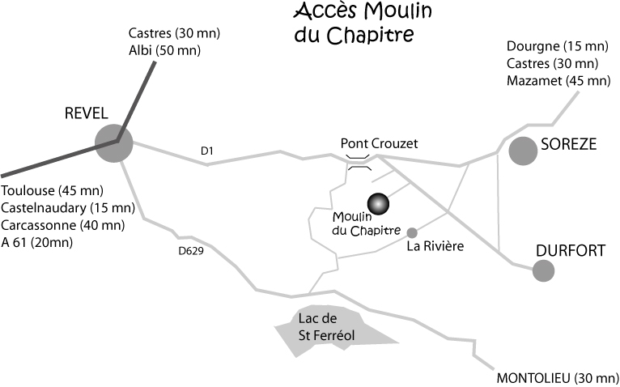
CARCASSONNE (45 mn)

